Attached is the lesson timetable for June. We will not be taking bookings until next week and here are the conditions, these may change as information from the government is updated.

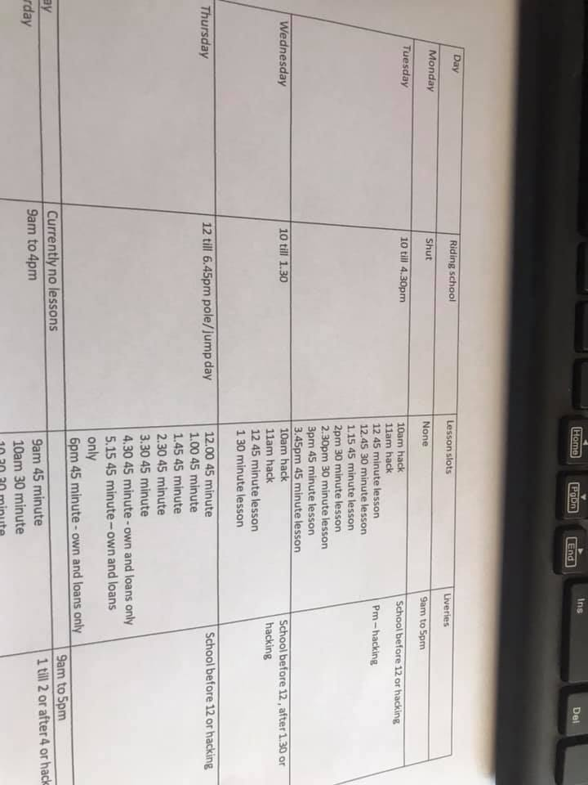

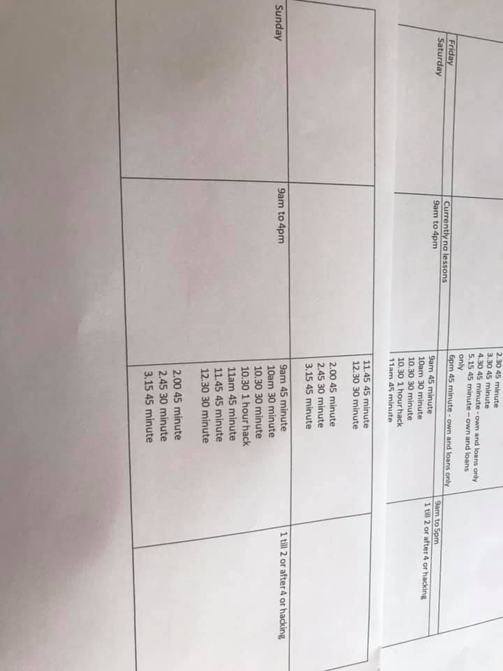
Only 1 to 1 lessons and hacks
no under 12's
riders must be able to walk trot and canter confidently
riders must be able to do their own stirrups and girths
riders must wear clean gloves
payment and bookings for the lesson must be done via phone in advance (you can put credit on your account so you do not need to keep paying)
you must have your own riding equipment you will not be able to borrow anything from us this includes a whip
we are not currently taking new clients on
you must fill an online rider registration form before your lesson(we will put a link up)
Due to the fact hacks are 1 to 1 the cost will be £40 for 1 hour
All lessons will be charged at PEAK PRICES
You must follow all instructions and directions on the yard , please do not use the toilets unless absolutely essential. Only come out of your car 5 minutes before the lesson, do not hang around the yard before or after. Please only vital spectors to come ( eg only 1 parent)
Any questions please ask - it will be a strange few months and I am sure things will keep changing!

